**HOTEL ORDERING APPLICATION**

**A PROJECT REPORT**

**SUBMITTED BY**

**CB.EN.U4CSE16647 V SIVA SURYA**

**CB.EN.U4CSE16649 R SUNDAR**

**CB.EN.U4CSE16651 P V VIGNESWAR**

**CB.EN.U4CSE16652 R VISHAL**

**CB.EN.U4CSE16653 S VIVEK SIDHAARTHAN**

# 

# TABLE OF CONTENTS

**Title Page No.**

**1. Project Abstract 3**

**2. Preview of the Project & SRS 4**

**3. Goals & Scopes 5**

****3.1 Deliverables 5****

****3.2 Scheduling & Estimates 6****

****3.3Tools used 6****

****4.** UML Diagrams 7**

**4.1 Use Case 7**

**4.2 Class 8**

**4.3Activity 9**

**4.4 Swimlane 10**

**4.5 Sequence 11**

**5. Agile Tools 12**

**5.1 Sonar Qube 13**

**5.2 Testing Whiz 14**

**5.3 Selenium 15**

**5.4 Katalon 16**

**6. Output Screenshots 16**

**Conclusion 19**

**Reference 19**

# ABSTRACT:

The objective of this project is to develop an Online Food Ordering Application. It is a web application that can enable customers to place their order online at any time and place according to their desired foods.

The subsystem is a reservation and booking platform to keep track of reservations and table availability. Both users types ,Customers and Manager, can access the Hotel Ordering Application. It is restricted for customers to check the availability and book the tables alone. A trace of the tables alloted to the Customer and the food ordered by them is stored in the database. Customers at the end of their meal can pen down their experiences which can improve the services provided in the hotel. Visitors can read the reviews and get to decide whether to order the food accordingly.

# SRS:

# Project Plan: Hotel Ordering Application

# Introduction

This Document lays out a project plan for the development of “Hotel Ordering Application” open source repository system by Siva Surya, Sundar, Vigneswar, Vishal, Vivek Sidhaarthan. The intended readers of this document are current and future developers working on “Hotel Ordering Application”. The plan will include, but is not restricted to, a summary of the system functionality, the scope of the project from the perspective of the “Hotel Ordering Application” team (me and my team members), scheduling and delivery estimates, project risks and how those risks will be mitigated, the process by which I will develop the project, and metrics and measurements that will be recorded throughout the project.

## Overview

The Software Requirements Specification (SRS) will provide a detailed description of the requirements for the Hotel Ordering Application. This SRS will allow for a complete understanding of what is to be expected of the Hotel Ordering Application to be constructed. This SRS will provide the foundation for the project. From this SRS, the Hotel Ordering Application can be designed, constructed, and finally tested. The software product to be produced is a Hotel Ordering Application which will automate the major hotel operation. The subsystem is a reservation and booking system to keep track of reservations and table availability. Both the users types (Customers and Manager) can access the Hotel Ordering Application. It is restricted for the customers to check the availability and book the tables alone.

## 2.1 Users

Anyone can use this application ranging from a child to an old-age person.

**2.2 Functionality**

* Customers should be able to choose between breakfast/lunch/dinner to order appropriate food.
* Customers would be able to choose food based on the price mentioned in the Menu.
* Customers should be able to choose the date and time that they wish to have food by checking the availability of tables.
* Customers should have the flexibility to choose the type of the table according to the headcount.
* Customers should be able to call off the reservation that they have made.
* People can choose their dietary preferences between Veg and Non-veg.
* People can order appetizer/main course/desserts from the Menu.
* People can make their own mode of payment through either Cash/Online payment.
* People should be updated with daily offers and rewards for Loyalty.
* Locations of the hotel in various cities.

**2.3 Platform**

**It will be launched as a Web-based Application.**

**3. Goals and Scopes**

* Customers should be able to choose between breakfast/lunch/dinner to order appropriate food.
* Customers would be able to choose food based on the price mentioned in the Menu.
* Customers should be able to choose the date and time that they wish to have food by checking the availability of tables.
* Customers should have the flexibility to choose the type of the table according to the headcount.
* Customers should be able to call off the reservation that they have made.
* People can choose their dietary preferences between Veg and Non-veg.
* People can order appetizer/main course/desserts from the Menu.
* People can make their own mode of payment through either Cash/Online payment.
* People should be updated with daily offers and rewards for Loyalty.
* Locations of the hotel in various cities.

****3.1 Deliverables****

I’ll deliver the following during the course of development:

* Feature specification.
* Product Design
* Test Plan
* Development document
* Source code

**3.2 Scheduling and Estimates:**

|  |  |  |
| --- | --- | --- |
| **Milestone** | **Description** | **Release Date** |
|  |  |  |
| M1 | Application view and Design |  |
|  | (Front-end development) |  |
| M2 | Database for my application |  |
|  | (Back-end) |  |
| M3 | Integrating views and designs |  |
|  | (Integrating front-end and |  |
|  | back-end) |  |
| M4 | Testing for initial release |  |
| M5 | Issue tracker, user reviews, |  |
|  | web design integration |  |
| M6 | Final release |  |

****3.3 Tools used :****

Following would be the languages I would use to develop my application within the stipulated time period:

Front-end development: HTML, CSS.

Back-end development: MongoDB.

**4.UML Diagrams:**

**4.1 Use Case:**

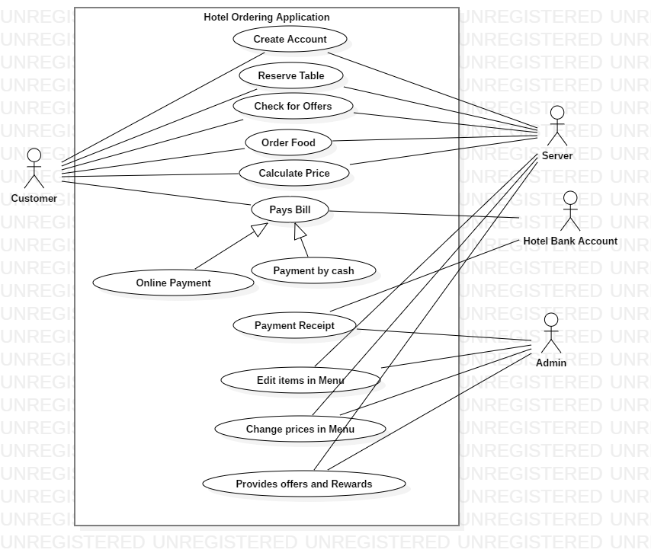

**4.2 Class Diagram:**

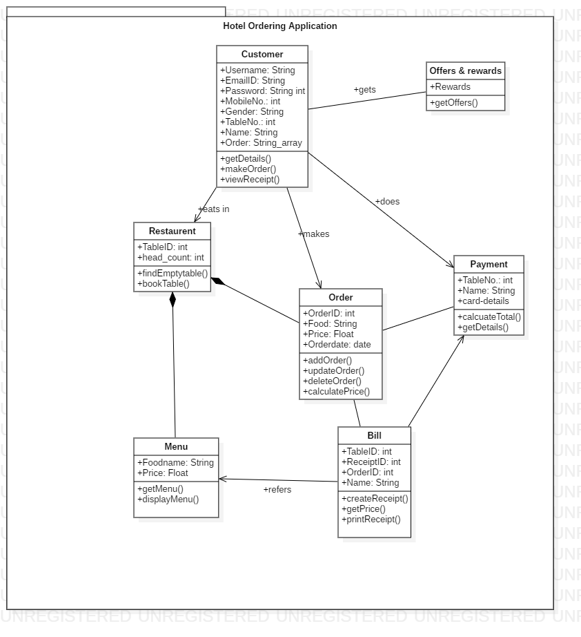

**4.3 Activity Diagram:**

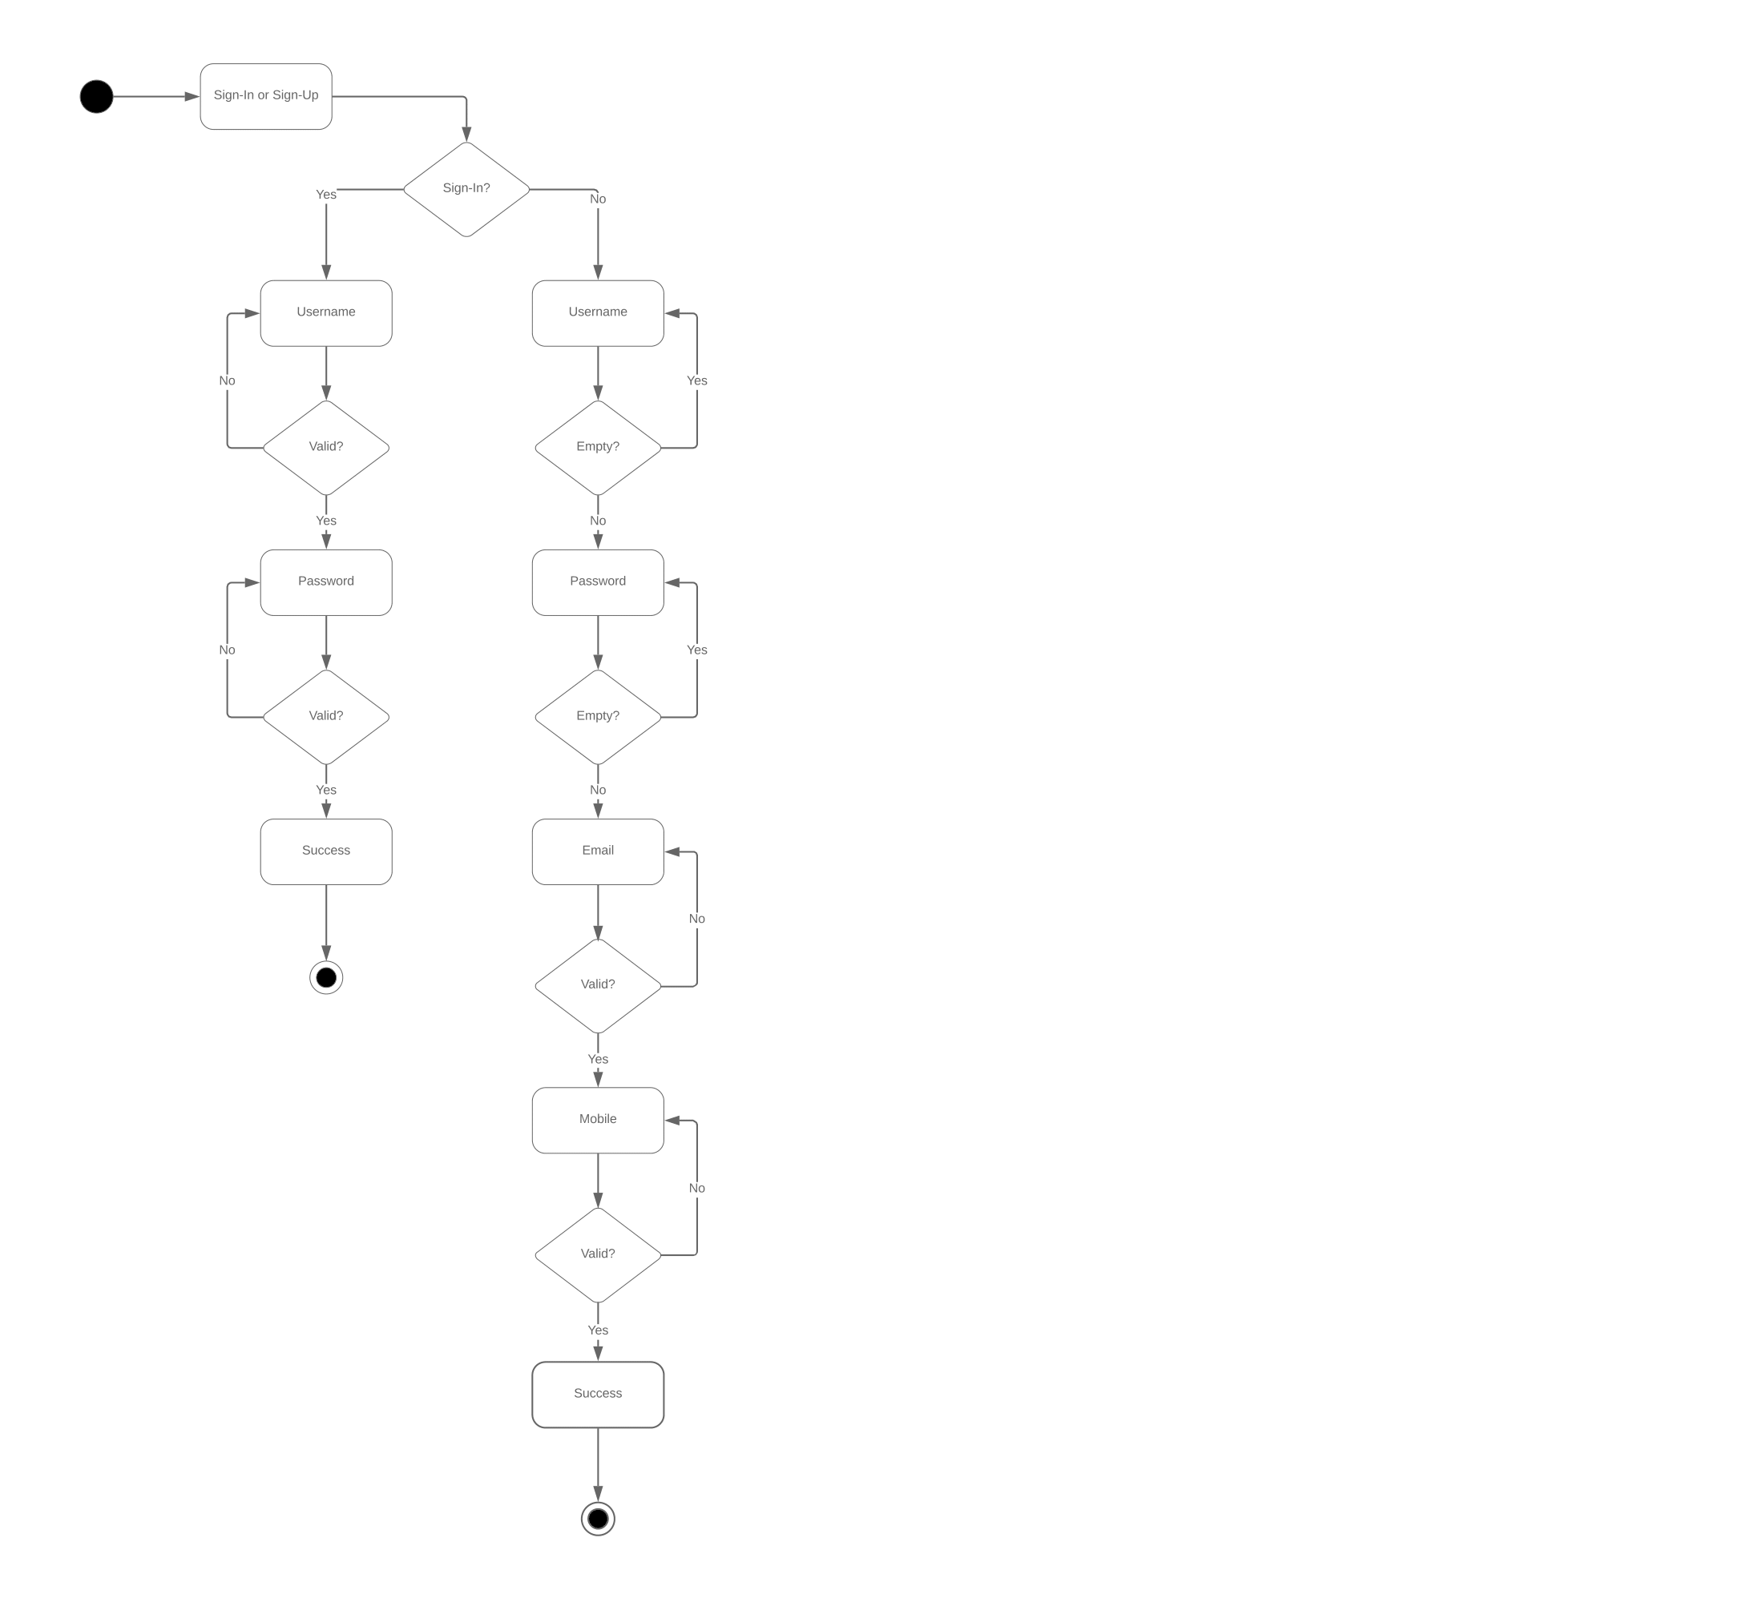

**4.4 Swimlane Diagram:**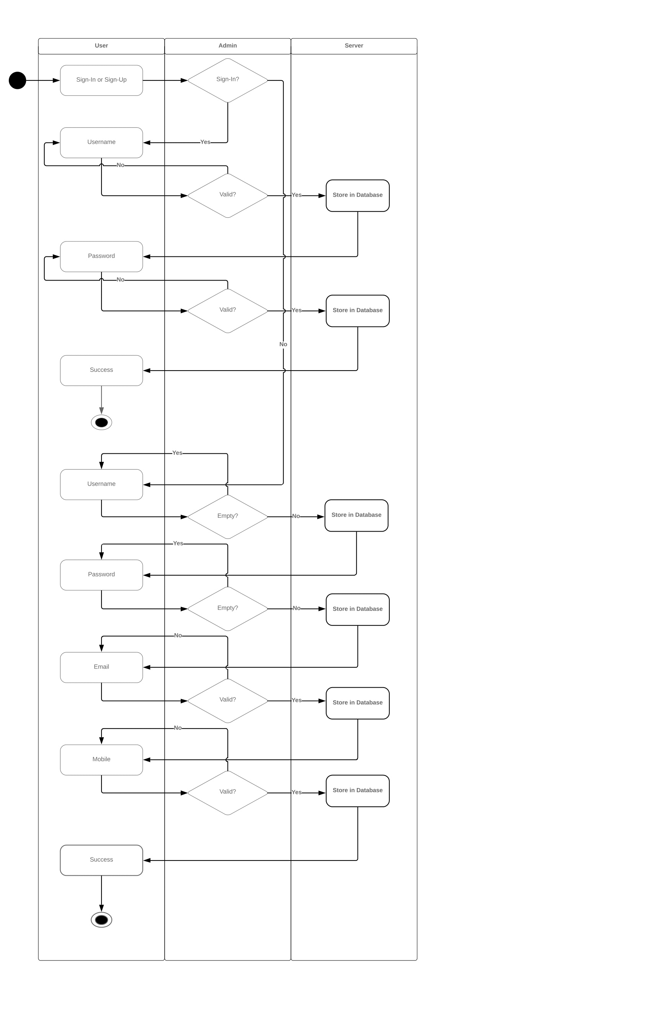

**4.5 Sequence Diagram:**

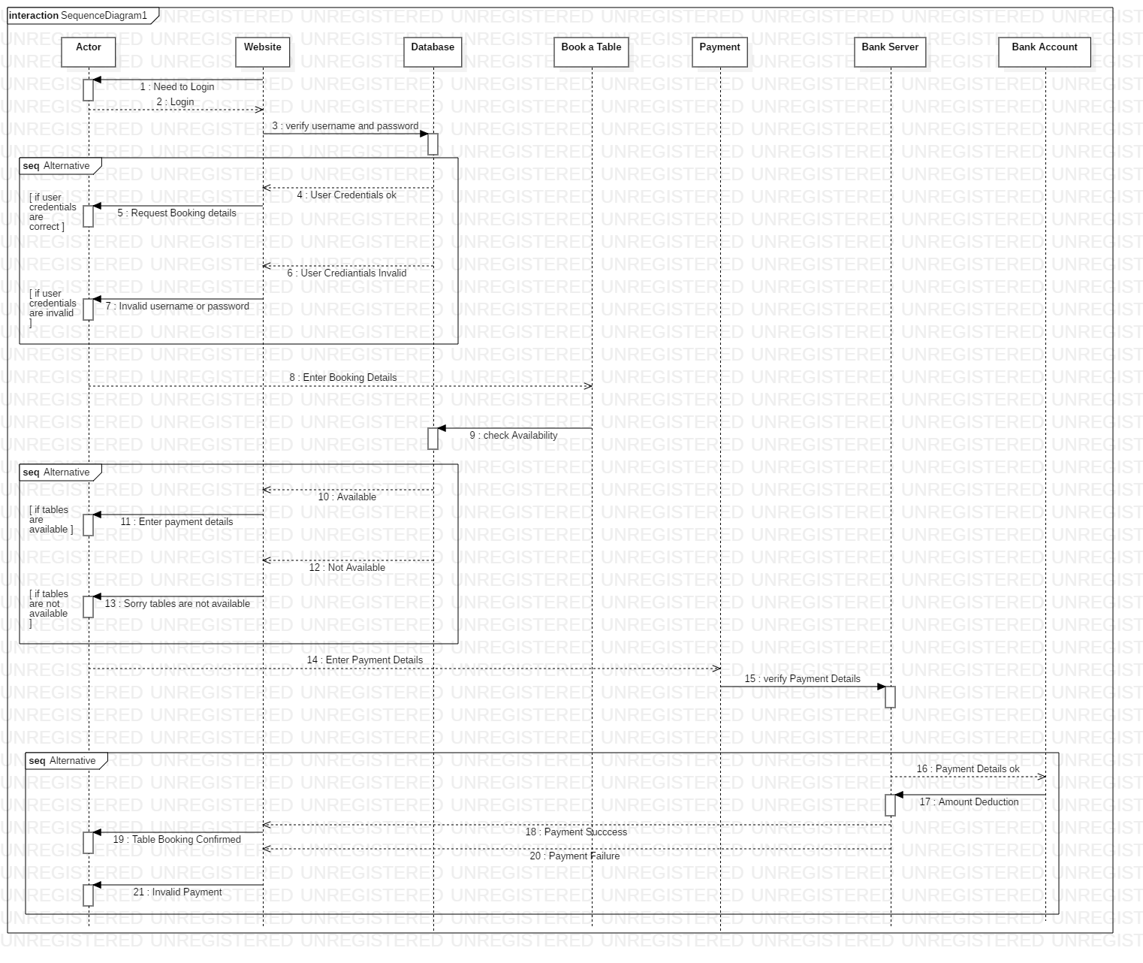

**5. AGILE TOOLS:**

**5.1 SonarQube:**

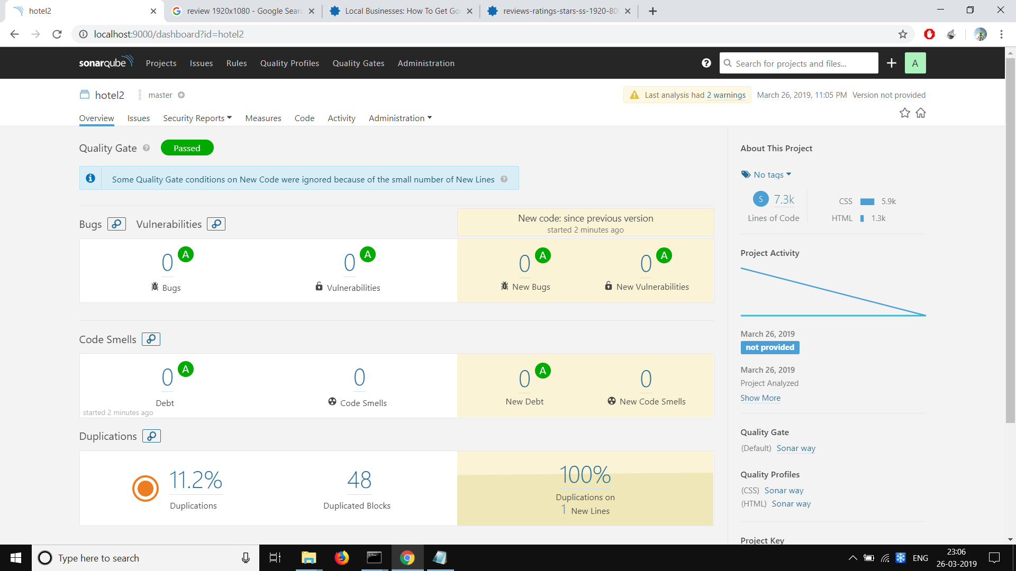

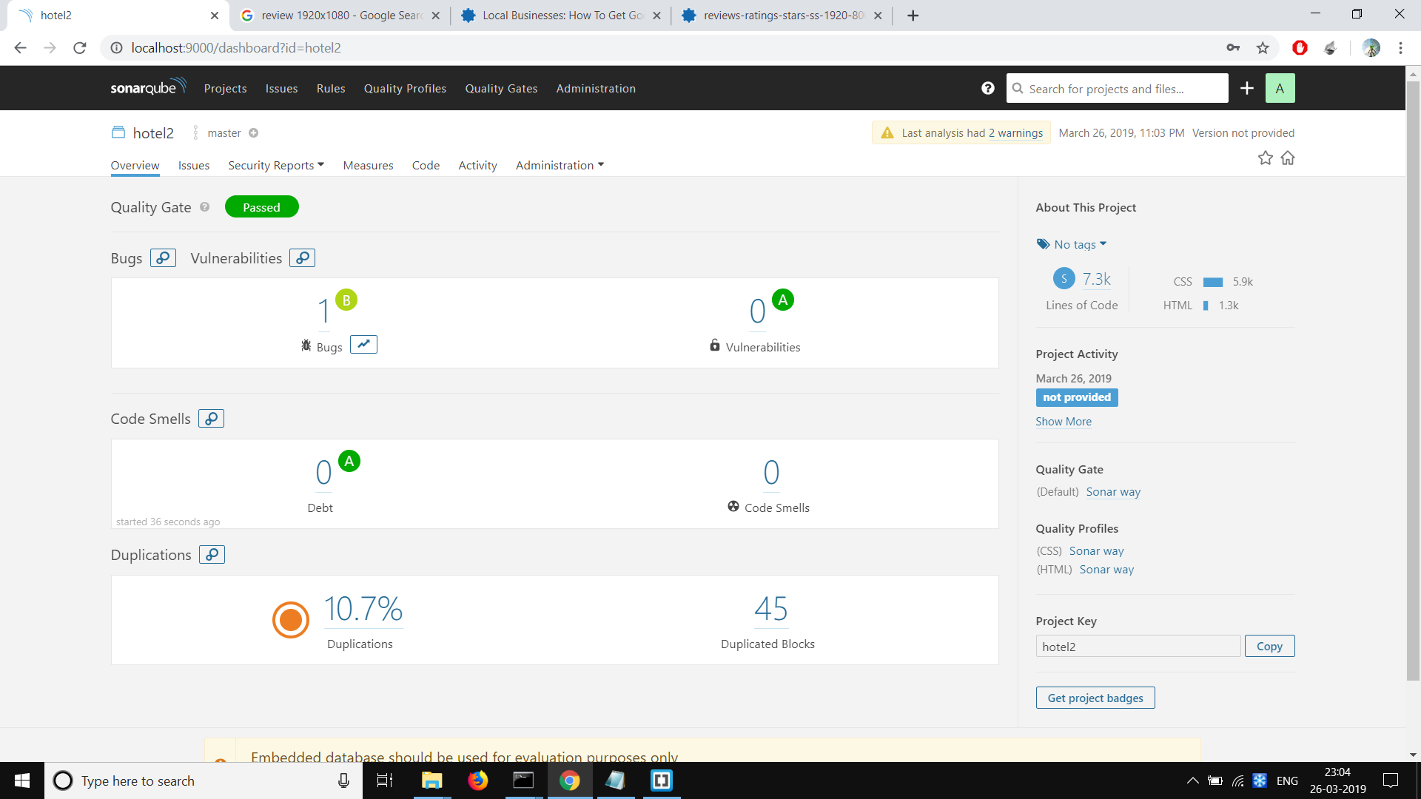

**5.2 TestingWhiz:**

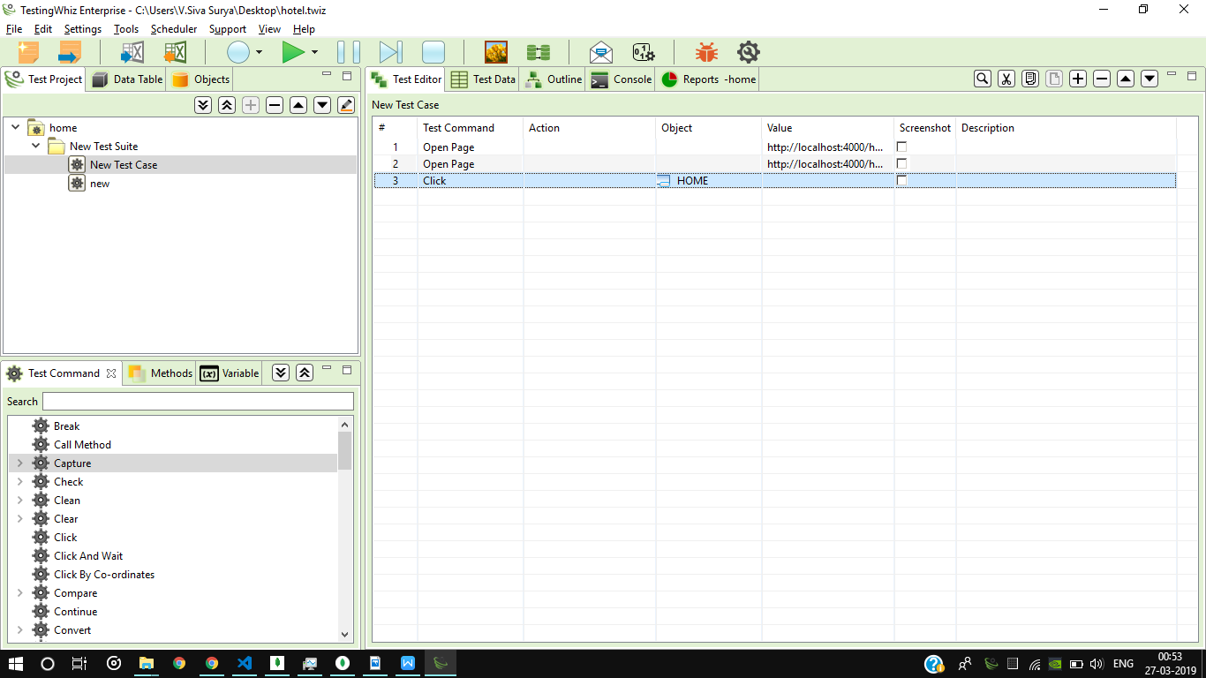

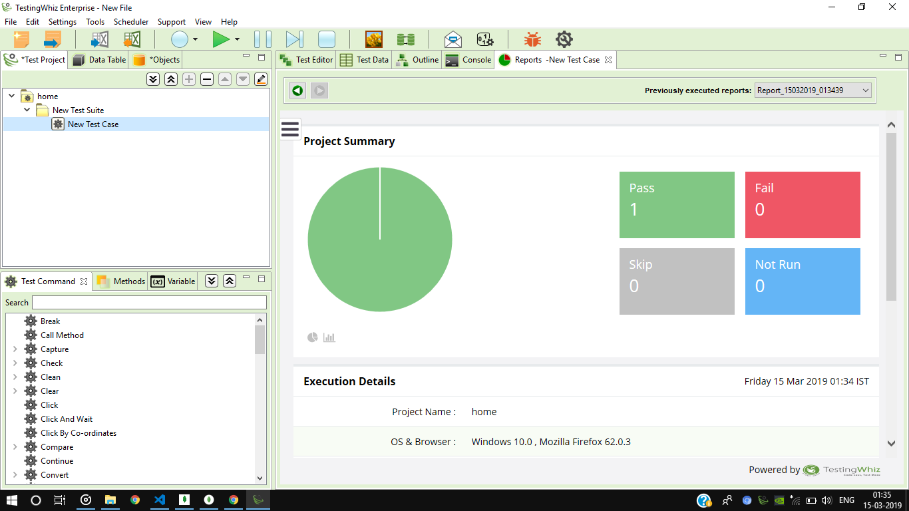

**5.3 Selenium :**

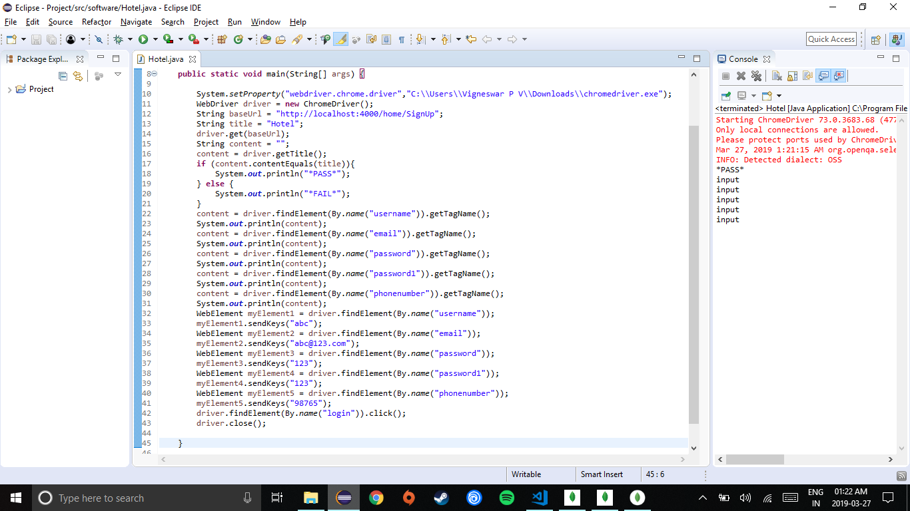



**5.4 Katalon**

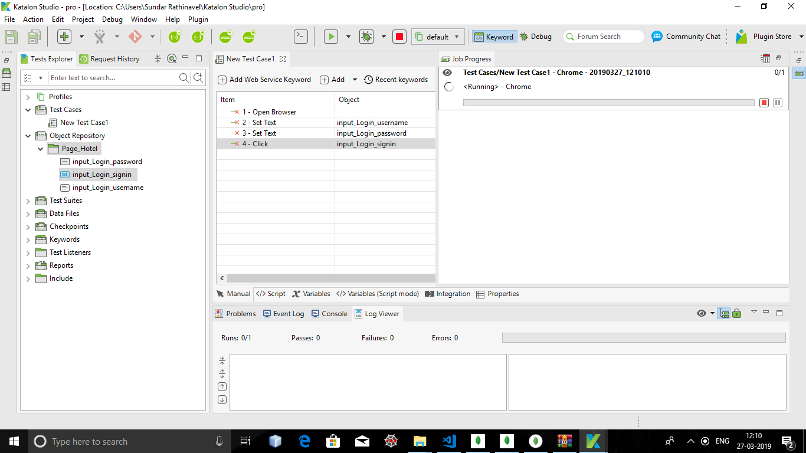

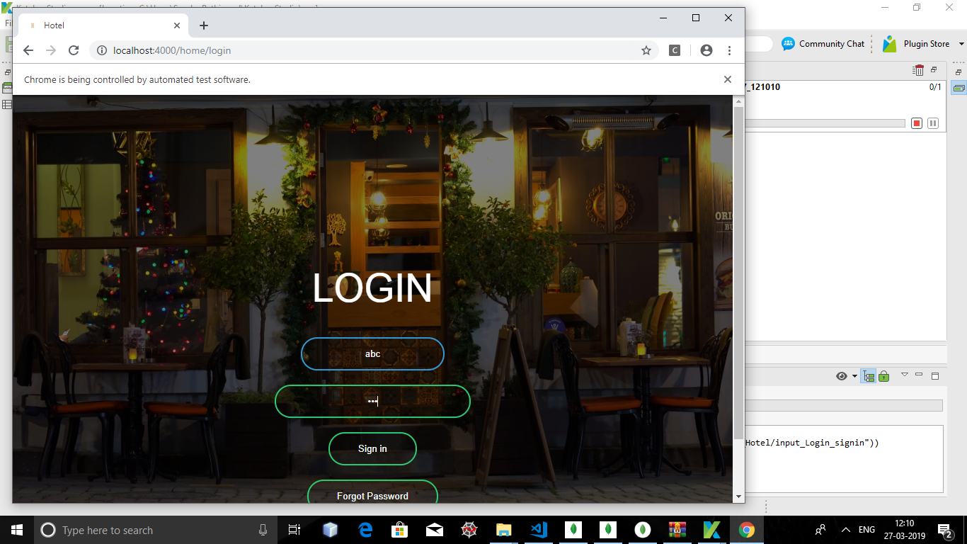

**6.OUTPUT SNAPSHOTS:**

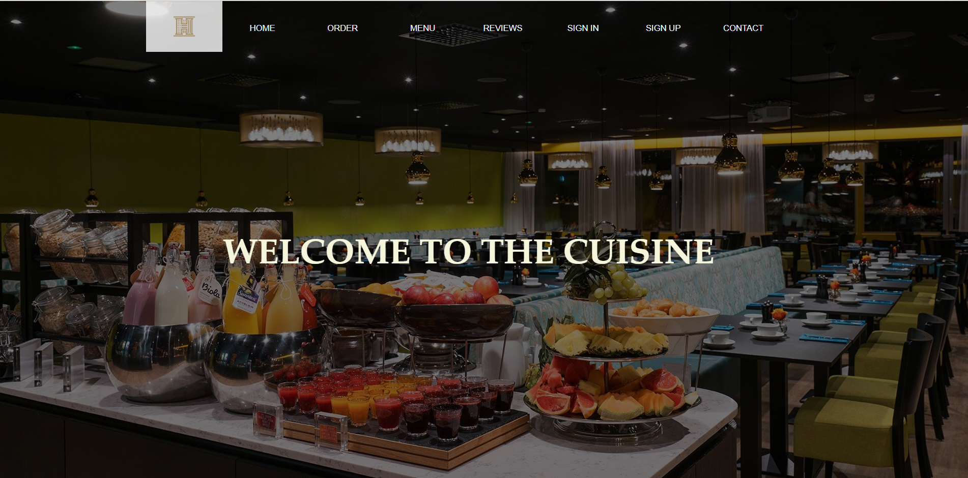

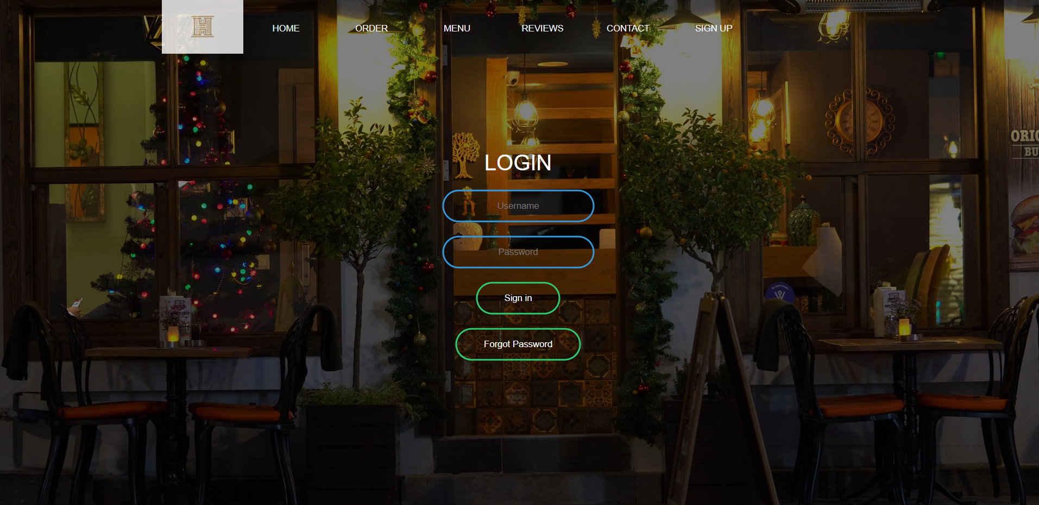

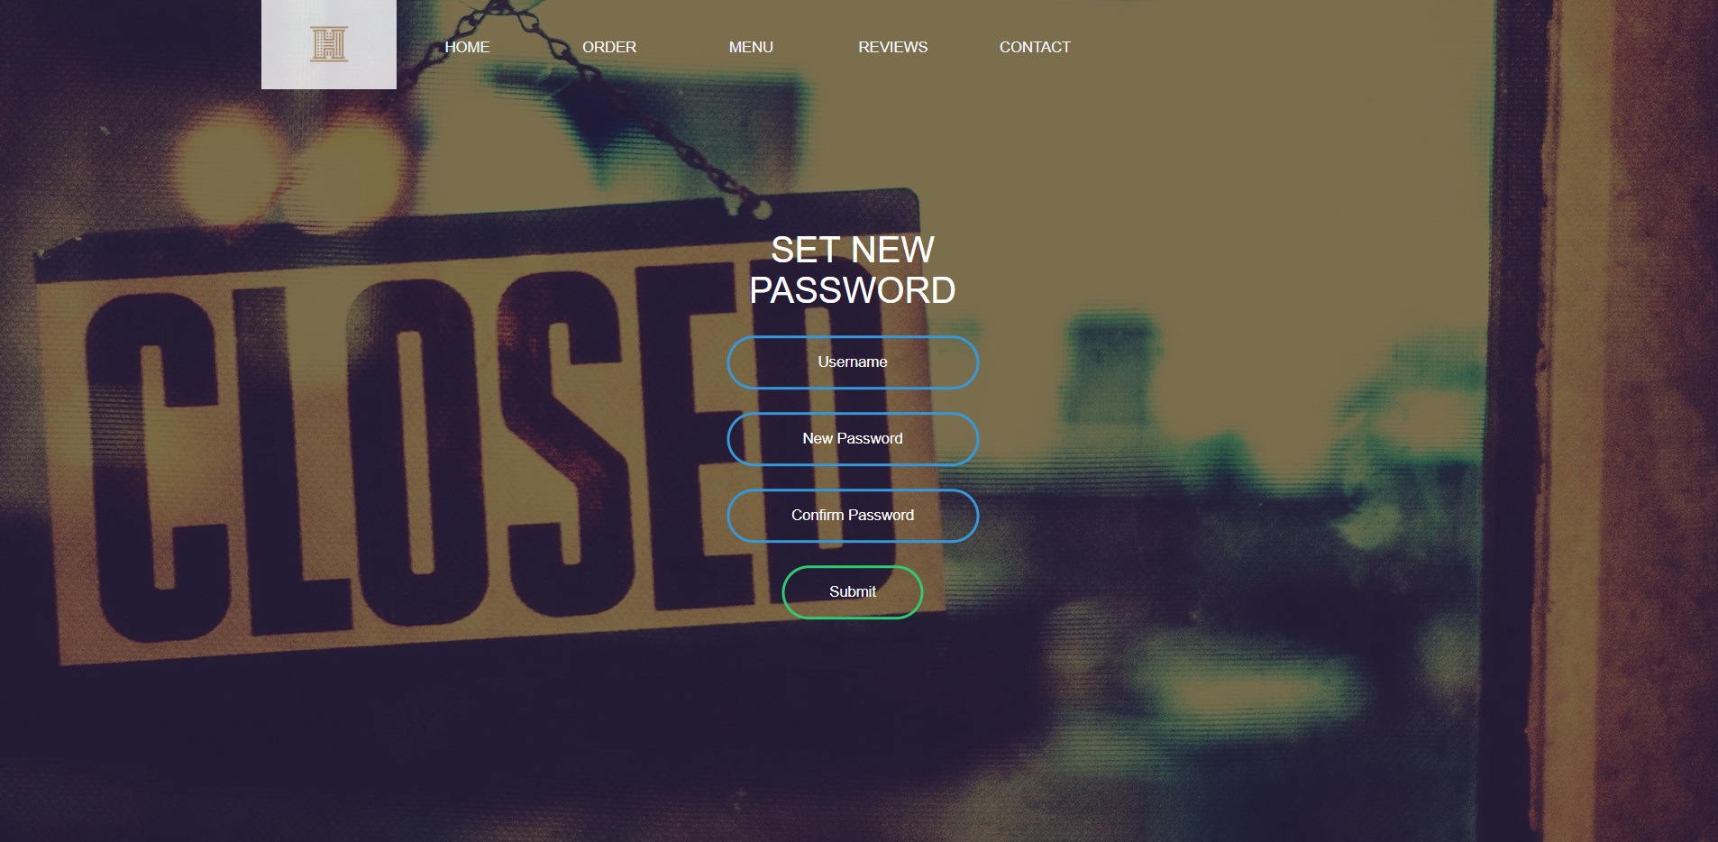

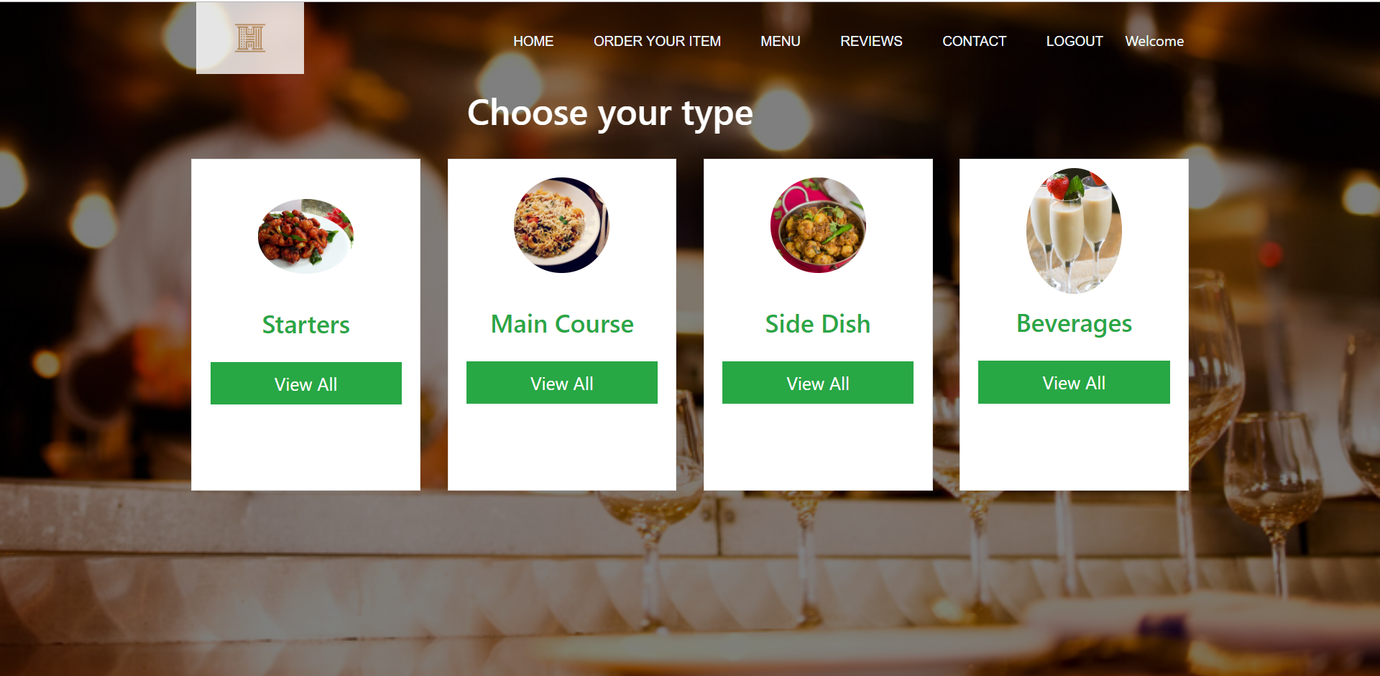

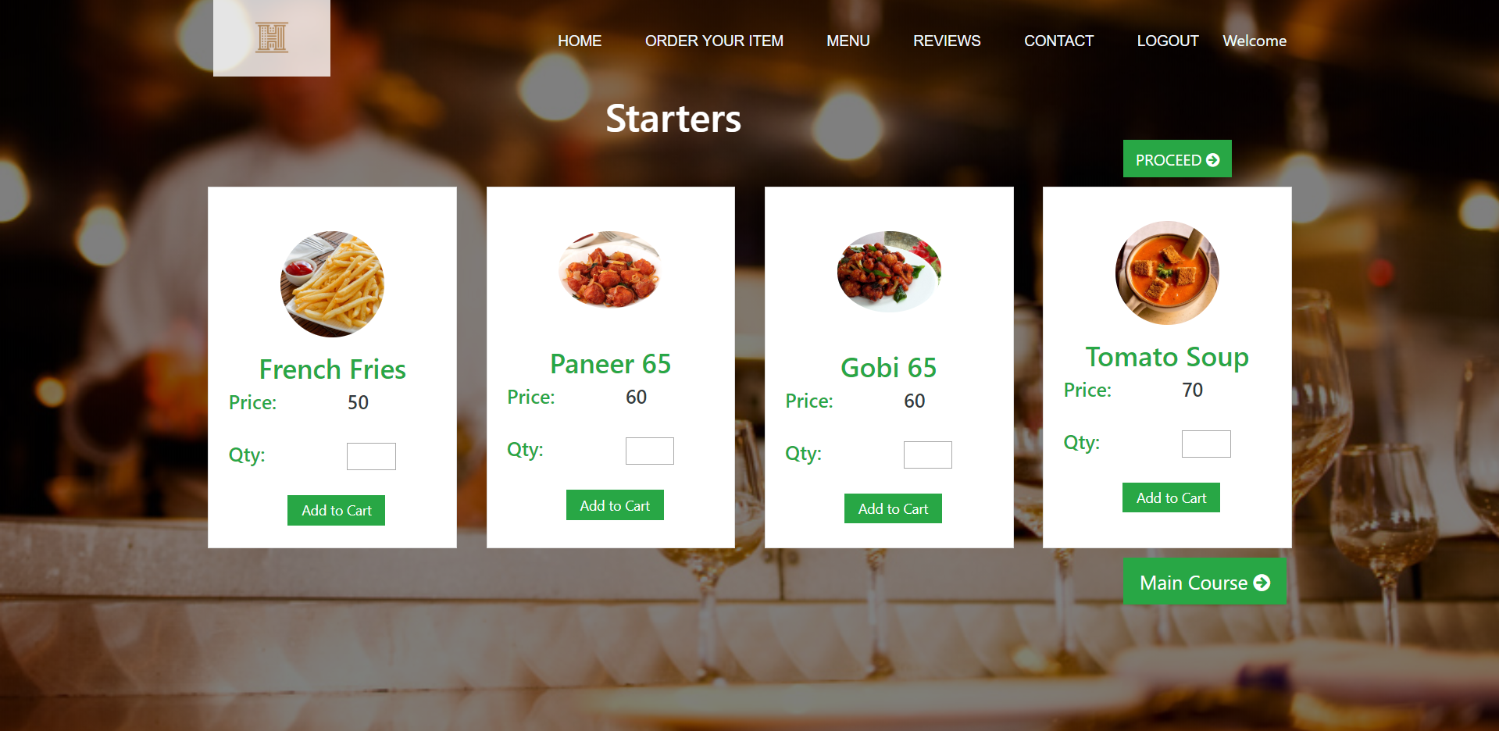

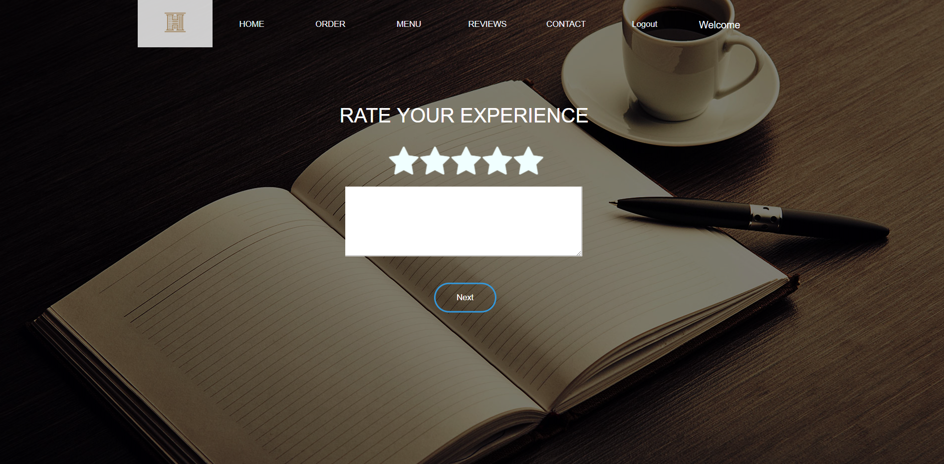

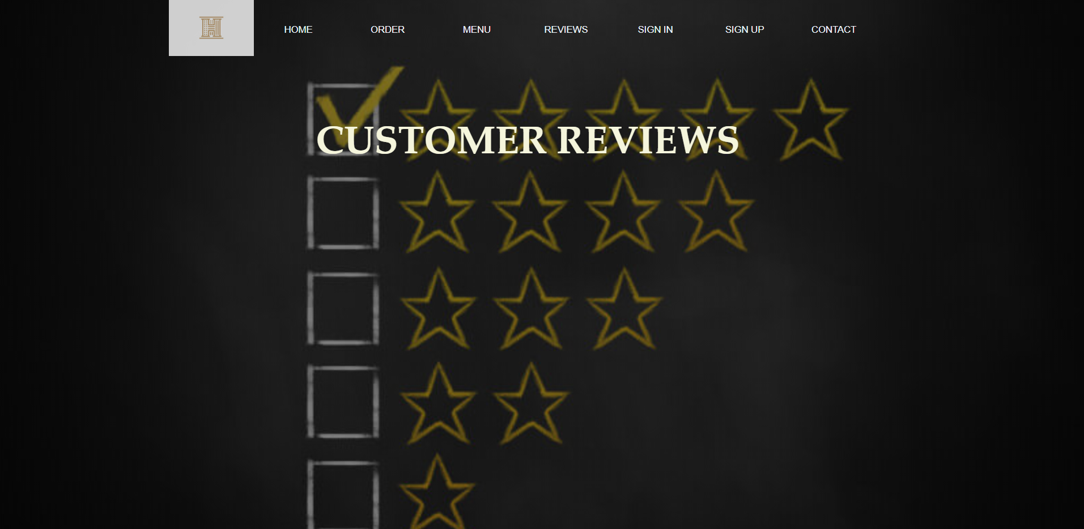

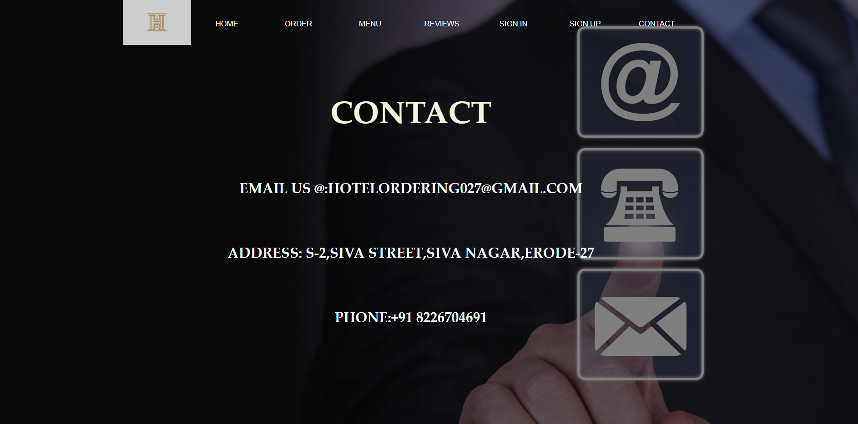

**CONCLUSION :**

**Customers can now feel instant gratification when their favourite food flows down their tongue.** This application will now serve for the needs for those in need of a platform to order their favourite food . People have the choice of visiting the hotel according to the experiences of the society.

**REFERENCE :**

<https://www.w3schools.com/css/>

<https://www.w3schools.com/html/>

<https://codeforgeek.com/category/database/mongodb/>

<https://www.youtube.com/>